
ABSTRACT

The concept of quizzes is currently very popular among educated circles as well Asin entertainment shows. Though the quiz can be conducted manually, it often needs elaborate preparations. Quizzes contribute to the growth of knowledge of an individual and they are a popular source of entertainment. This program In C++ focuses on creating interactive quizzes possibly with a large database of questions from various subjects. The program utilizes most of the important concepts in C++. The final output is envisioned to be a user-friendly interactive quiz with which the user can gain significant knowledge and get entertainment with value-addition.

A quiz is a quick and informal assessment of student knowledge. Quizzes are often used in North American higher education environments to briefly test a students' level of comprehension regarding course material, providing teachers with insights into student progress and any existing knowledge gaps.

TABLE OF CONTENTS

1. INTRODUCTION 01-02

1.1 Overview of the project 01

1.2 Problem Statement……………........................................................... 01

1.3 Existing System 01

1.4 Proposed System…………………….……………….……………... 01

1.5 Advantages…………………………………………………………… 02

1.6 Dataflow Diagram…………………………………………………… 02

2. REQUIREMENT SPECIFICATION 03

2.1 System requirements 03

2.1.1 Hardware requirement………………………………….......... 03

2.1.2 Software requirement……………………………………….. 03

2.2 Software description 03

3. FILE OPERATION 04-14

3.1 File Structure 04

3.1.1 Primary Index………………………………………… 04

3.2 Testing 05

3.2.1 Unit Testing 05

3.2.2 Integrated Testing……………………………................... 05

3.2.3 System Testing…………………………………….……. 06
3.3 Test Case……………………………………………………..……... | 06
3.4 Unit Testing……………………………………………………...….. | 07
4. IMPLEMENTATION…………………………………………………….. | 08-14
5. SNAPSHOTS………………………………………………………………. | 15-17
6. CONCLUSION……………………………………………………………. | 18
7. REFERENCES……………………………………………………………. | 19
QUIZ GAME | 2021-22

CHAPTER 1

INTRODUCTION

1.1 Overview of the project

This quiz game is designed to display certain questions onto the screen and the user guesses the correct answer. If the user enters the correct choice, then it will add 5 points to the total score and if a user is unable to guess the correct answer, then no negative marking will be performed. The total score at the end of this game is 50.

1.2 Problem Statement

Quiz is started by displaying one question with our options each based on programming language if the answer is correct score is incremented by five and no negative marks for wrong answers.

1.3 Existing System

Existing system is a manual one in which users are maintaining Data to store the information like Student Details, Instructor Detail ,Schedule Details and feedbacks about students who attempted Quiz as per schedule.. It is very difficult to maintain historical data.

1.4 Proposed system

This application is used to conduct online Quiz Game. The students can sit at individual terminals and Enter there Detail to Conduct and Quiz in the given duration. The questions have to be given to the students. This application will perform correction, display the result immediately and also store it in database. This application provides the administrator with a facility to add new Question. This application provides the instructor add questions to the Quiz, modify questions in the Quiz in a particular as a Game. This application takes care of authentication of the administrator, Instructor as well as the User.

Dept. of ISE, MIT MYSORE Page 1
QUIZ GAME | 2021-22

1.5 Advantages

- Besides quizzes can be conducted for technical student and over varying cultures.

- Quizzes improve or expanding one’s knowledge of things, either general or in specific area.
- Quizzes are designed to promote, a fun way to study and in the process, help improve one’s knowledge.

- Quiz competitions enables students to think from different angles or simply ‘to think out of the box’.
- It promotes a healthy debate amongst participants in order to learn from each others.

1.6 DataFlow Diagram
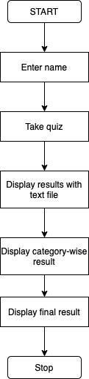

Fig:1.6.1 Dataflow Diagram

Dept. of ISE, MIT MYSORE Page 2
QUIZ GAME | 2021-22

CHAPTER 2

SOFTWARE REQUIREMENT SPECIFICATIONS

2.1 System Requirements

2.1.1 Hardware Requirements:

PROCESSOR: Pentium 3 and higher (1.2GHZ and higher)

RAM : 4GB and higher

HARD DISK: 20GB

2.1.2 Software Requirements:

Operating system: Windows XP/7.

Coding Language: C++

2.2. Software description

- C++ (Language used):

C++ is a general-purpose programming language. It has imperative, object-oriented and generic programming features, while also providing facilities for low level memory manipulation.

It was designed with a bias towards system programming and embedded, resource-constrained and large systems, with performance, efficiency and flexibility of use as its design highlights. C++ has also been found useful in many other contexts, with key strengths being software infrastructure and resource-constrained application, including desktop applications, servers (example: e-commerce, web search or SQL servers), and performance-critical applications (e.g.: telephone switches or space probes.). C++ is a complied language, with implementations of it available on many platforms. Many vendors provide C++ compilers, including the free Software Foundation, Microsoft, Intel and IBM.

Dept. of ISE, MIT MYSORE Page 3
QUIZ GAME | 2021-22

CHAPTER 3

FILE OPERATIONS

3.1 File Structure
Operation |  | Input | Output
1.Insertion |  | We will insert all the details of the User | All the details are inserted.
Identification |  | name which will be stored in a respective
 |  | file record.
2. | Play Quiz | Student/user can play the quiz according | All the Question records will be
 |  | to his/her choice | displayed.
3. | Quiz Questions | When we need a particular name detail to | The corresponding details and
 |  | be obtained, random questions. Based on | Questions are obtained
 |  | programing types and language.
4. | Results and Score | Student/user attempted the quiz and gets | Modified the total score of
 |  | a result. | users.


3.1.1 Primary Index:

Index on Sequential File, also called Primary Index, when the Index is associated to a Data File which is in turn sorted with respect to the search key.

- A Primary Index forces a Sequential file organization on the Data File;

- Since a Data File can have just one order there can be just one Primary Index for Data File. Usually used when the search key is also the Primary key of the relation. Usually, these indexes fit in main memory. Indexes on sequential files can be:

- Dense: One entry in the index file for every record in the data file.

- Sparse: One entry in the index file for each block of the data file.

Dept. of ISE, MIT MYSORE Page 4
QUIZ GAME | 2021-22

3.2 Testing:

The purpose of testing is to discover errors. Testing is the process of trying to discover every conceivable fault or weakness in a work product. It provides a way to set the functionality of components, sub-assembly and/or a finished product. It is the process of exercising software with the intent of ensuring that a software system meets its requirements and user expectation does not fail in an unexpectable manner. There are various types of tests. Each test type addresses a specific testing requirement.

Types of Testing:

3.2.1 Unit Testing:

Unit testing is a software testing method by which individual units of source code, sets of one or more computer program modules together with associated controlled data, usage procedures and operating procedures are tested to determine whether they are fit for use.

The primary goal of Unit testing is to take the smallest piece of testable software in the application, isolate it from the reminder of the code and determine whether it behaves exactly as you expect. Each unit is tested separately before integrating them into modules to test the interfaces between modules. Unit Testing has proven its value in that a large percentage of defects are identified during its use.

3.2.2 Integrated Testing:

Integration testing is the logical extension of unit testing. In its simplest form, two units that have already been tested are combined into a component and the interface between them is tested. A component, in this sense, refers to an integrated aggregate of more than one unit. In a realistic scenario, many units are combined into components, which are in turn aggregated into even larger parts of the program. The idea is to test combinations of pieces and eventually expand the process to test your modules with those of other groups. Eventually all the modules making up the process are tested together. Beyond that, if the program is composed of more than one process, they should be tested in pairs rather than all at once.

Dept. of ISE, MIT MYSORE Page 5
QUIZ GAME | 2021-22

3.2.3 System Testing:

The process of performing a variety of tests on a system to explore functionality or to identify problems is called System Testing. It is usually required before and after a system is put in place. A series of systematic procedures are referred to while testing is being performed. These procedures tell the tester how the system should perform and where common mistakes may be formed. Testers usually try to “Break the system” by entering data that may cause the system to malfunction or return incorrect information. For example, A tester may put in a city in a search engine design to accept only states, to see how the system responds to the incorrect inputs.

3.3 Test Case:

Test case is a set of test inputs, execution and expected results developed for a particular objective.
An excellent test case satisfies the following criteria:

- Reasonable probability of catching errors.

- Does interesting things.

- Doesn’t do unnecessary things.

- Neither too simple nor too complex.

- Allows isolation and identification of errors.

Dept. of ISE, MIT MYSORE Page 6
QUIZ GAME | 2021-22

3.4 Unit Testing:

TEST | TEST | TEST |  |  | INPUT | EXPECTED |  | ACTUAL |  | RESULT
CASE | CASE | CASE |  |  |  | RESULTS |  | RESULT
ID | NAME | DESCRIPTION
TC 01 | File | Enter | the | good | view | Displayed the |  | Displayed |  | PASS
 | managem | name |  |  | content | name |  | and stored
 | ent |  |  |  | enters |  |  | in backend
 |  |  |  |  | the
 |  |  |  |  | name
TC 02 | File | Validate Quiz game |  |  | choose | Marked | choose | Marked |  | PASS
 | managem | questions details |  |  | shown | option |  | choose
 | ent |  |  |  | answer | successfully |  | option
 |  |  |  |  | option |  |  | successfull
 |  |  |  |  |  |  |  | y
TC 03 | Quiz | Validate Quiz game |  |  | Student/ | Student | /users | Student |  | PASS
 | Game | questions |  | score | users | details should be |  | /users
 | managem | update |  |  | score are | updated |  | details
 | ent |  |  |  | changed | successfully |  | should | be
 |  |  |  |  | and |  |  | updated
 |  |  |  |  | update |  |  | successfull
 |  |  |  |  |  |  |  | y
TC 04 | Quiz | Validate Quiz game |  |  | score is | Score should be |  | Score |  | PASS
 | Game | questions |  | score | changed | change | updated | should | be
 | managem | update |  |  | and | successfully |  | change
 | ent |  |  |  | update |  |  | updated
 |  |  |  |  |  |  |  | successfull
 |  |  |  |  |  |  |  | y
TC 05 | Result | Validate Quiz game |  |  | Display | Score should be |  | Score |  | PASS
 |  | questions |  |  | result | Displayed |  | should | be
 |  |  |  |  |  |  |  | Displayed
TC 06 | Result | Invalid | Quiz | game | Invalid | Should | display | Program |  | FAIL
 |  | Option |  |  | Option | Invalid Option |  | continues


Table 3.4: Unit Testing

Dept. of ISE, MIT MYSORE Page 7
QUIZ GAME | 2021-22

CHAPTER 4

IMPLEMENTATION

Source code:

#include <iostream>

#include <fstream>

#include <string>

#include <ctime>

#include <cstdlib>

#include <algorithm>

using namespace std;

string allCategories[10];

int marksPerCategory[10];

int k=0;

void questionAsked(string option,string option1,string option2,string option3,string option4,string correct,string category,ofstream& fp,int *score) {

cout << "Choose Your Option : ";

cin >> option;

transform(option.begin(), option.end(), option.begin(), ::toupper); // for converting lowercase to uppercase

option.append(")");

fp<<"Question "<<category<<endl;

if (option[0] == correct[0])

{

if (option[0] == option1[0])

{

fp << "Correct Answer : " << option1 << endl;

Dept. of ISE, MIT MYSORE Page 8

QUIZ GAME
2021-22

fp << "Your Answer

: " << option1<<endl;

}

if (option[0] == option2[0])

{

fp << "Correct Answer : " << option2 << endl;

fp << "Your Answer : " << option2<<endl;

}

if (option[0] == option3[0])

{

fp << "Correct Answer : " << option3 << endl;

fp << "Your Answer : " << option3<<endl;

}

if (option[0] == option4[0])

{

fp << "Correct Answer : " << option4 << endl;

fp << "Your Answer : " << option4<<endl;

}

marksPerCategory[k-1] = 5;

*score += 5; // updating total score

fp<<" Marks Awarded = 5 "<<endl;

}

else

{

string correctanswer;

if (correct[0] == option1[0])

correctanswer = option1;

if (correct[0] == option2[0])

correctanswer = option2;

if (correct[0] == option3[0])

correctanswer = option3;

if (correct[0] == option4[0])

correctanswer = option4;

Dept. of ISE, MIT MYSORE Page 9

QUIZ GAME | 2021-22

string wronganswer;

if (option[0] == option1[0])

wronganswer = option1;

if (option[0] == option2[0])

wronganswer = option2;

if (option[0] == option3[0])

wronganswer = option3;

if (option[0] == option4[0])

wronganswer = option4;

fp << "Correct Answer : " << correctanswer << endl; fp << "Your Answer : " << wronganswer << endl; fp << "Marks Awarded = 0 "<<endl;

marksPerCategory[k-1] = 0;

}

fp<<"\n-----------------------------------------------------------------------------\n";

}

int main()

{

string name;

cout<<"\n\n\n\t\t\t\tQUIZ APPLICATION in C++\t\t\t\t\n\n\n";

cout<<"Enter your name : ";

getline(cin,name);

cout<<"\n\nDear "<<name<<","<<endl<<"Please go through the below mentioned points before starting the quiz :-\n\n"<<endl;

cout<<"(1) Marks awarded for each correct answer = 5\n";

Dept. of ISE, MIT MYSORE Page 10
QUIZ GAME | 2021-22

cout<<"(2) Total number of questions = 10\n"; cout<<"(3) Maximum score of the quiz = 50\n"; cout<<"(4) There is no negative marking\n";
cout<<"(5) Detailed score card will be shown after attempting all 10 questions\n";

cout<<"\n\nBest of Luck !\n\n";

system("pause");

system("cls");

ifstream read("quiz_data.txt");

ofstream writeResult("op.txt");

string text;

string option1, option2, option3, option4,option,correct,category; int score = 0;
int arr[30]; //total questions present inside the file is 30

for (int i = 0; i < 30; i++)

{

arr[i] = 10 * i + 1;

}

for (int j = 0; j < 10; j++)

{

//total questions that can be asked in the quiz is 10

srand(time(NULL));

int x = rand()%3;

int end = (3 * j) + x;

// generating any random number from 0,1,2

for (int i = arr[3*j]; i < arr[end]; i++)

{

string empty;

getline(read, empty);

}

for (int i = 1; i <= 10; i++)

{

Dept. of ISE, MIT MYSORE Page 11

QUIZ GAME | 2021-22

getline(read, text);

if(i==1)

{

cout<<"\n\n\n\n\n\nQ"<<j+1<<") "<<text;

writeResult<<"\nQuestion Number : "<<j+1;

}

if(i==2)

{

writeResult<<text<<endl;

}

if(i==3)

option1 = text;

if(i==4)

option2 = text;

if(i==5)

option3 = text;

if(i==6)

option4 = text;

if (i>1 && i<= 7)

cout << text << endl;

if (i == 8)

correct = text.substr(0, 40);

if (i == 9)

{

category = text.substr(0, 40); allCategories[k] = category;

Dept. of ISE, MIT MYSORE Page 12
QUIZ GAME | 2021-22

k++;

}

}

questionAsked(option, option1, option2, option3, option4, correct, category,writeResult,&score);

- below is the condition for non-repetition of the questions if (arr[end] + 10 < arr[3 * (j + 1)])

{

for (int i = arr[end] + 10; i < arr[3 * (j + 1)]; i++)

{

string empty; getline(read, empty);
}

}

system("cls");

}

cout<<"Congratulations "<<name<<". You have completed the quiz.\n\n"; cout<<"You have got "<<score/5<<" correct out of 10 questions.\n\n"; cout<<"Here are your answers :-\n\n";

read.close();

writeResult.close();

ifstream resultFileRead("op.txt");

string readResult;

while(getline(resultFileRead,readResult))

{

cout<<readResult<<endl;

}

Dept. of ISE, MIT MYSORE Page 13
QUIZ GAME | 2021-22

cout<<endl<<endl;

system("pause");

cout<<"\n\nCategory wise marks is as follows :-\n\n";

for(int i=0; i<10; i++){

cout<<allCategories[i]<<" -> "<<marksPerCategory[i]<<" Marks"<<endl;

}

cout<<endl<<endl;

system("pause");

cout<<"\n\nYour Final Total Score : "<<score<<" out of 50.\n\n";

return 0;

}

Dept. of ISE, MIT MYSORE Page 14
QUIZ GAME | 2021-22

CHAPTER 5

SNAPSHOTS

Step 1:Enter your name in the console
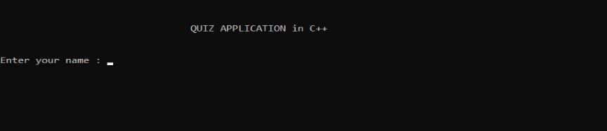

Fig.4.1 : Displaying name

Step 2:Follow the Rules and Regulations
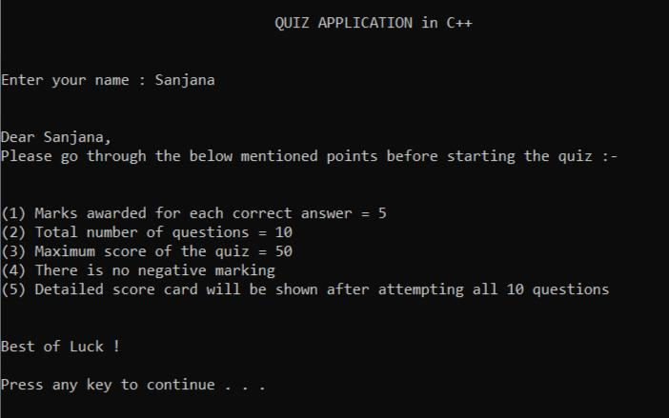

Fig.4.2 : Displaying Rules and Regulations

Step 3:Questions will be displayed one after the other
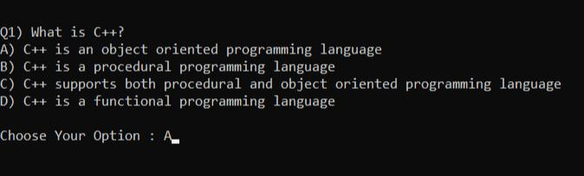

Fig.4.3 : Questions will be displayed

Dept. of ISE, MIT MYSORE Page 15
QUIZ GAME | 2021-22

Step 4:The correct answer will be displayed
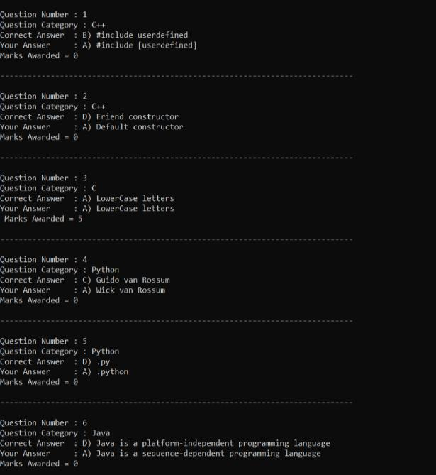
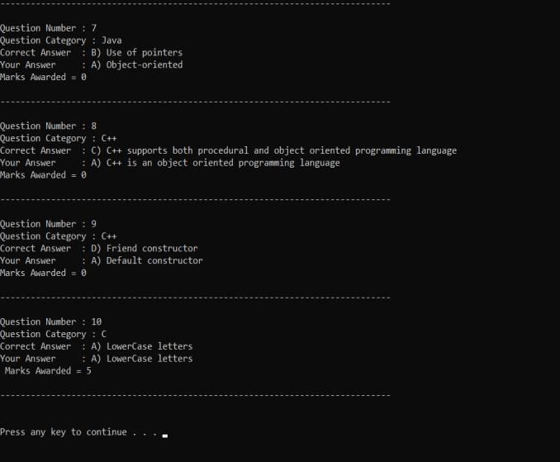

Fig.4.4 : correct answer is displayed

Dept. of ISE, MIT MYSORE Page 16
QUIZ GAME | 2021-22

Step 5:Language choosen for each question
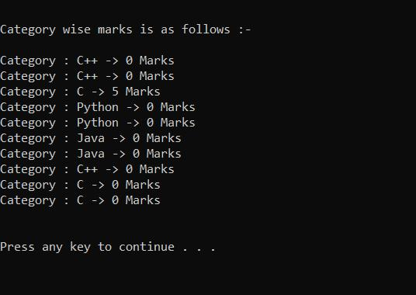

Fig.4.5 : category of languages used

Step 6: Result will be displayed and can exit page
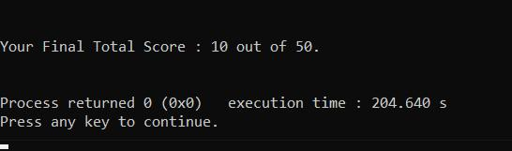

Fig.4.6 : Result is Shown

Dept. of ISE, MIT MYSORE Page 17
QUIZ GAME | 2021-22

CONCLUSION

This online quiz application provides facility to play quiz anywhere and anytime. It saves time since user does need to wait for result. So, student/user cannot wait for the result. All Student/ user get extra knowledge and skills. Administrator has a privilege to put as much as question in any category given in application. User can register, and give the test with his/her specific Name, and can see the results as well.

Dept. of ISE, MIT MYSORE Page 18
QUIZ GAME | 2021-22

REFERENCES

- File structures - C++

- Textbook - Michael J. Folk, Bill Zoellick, Greg Riccardi: File Structures-An Object Oriented Approach with C++

- Stack Overflow

- https://www.academia.edu/34579184/Quiz_Contest_A_Quiz_Application_A_PROJE CT_R EPORT_Submitted_by_NAME

- T4Tutorials - https://t4tutorials.com/quiz-game-project-in-c/

Dept. of ISE, MIT MYSORE Page 19

